

Inspection Report
Prepared For:
Investor
Property Address:
7831 Martha Washington Street
Alexandria, VA 22309
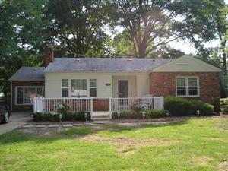

Scorpion Home Inspections, Inc.
Michael Edwards
265 Cedar Ridge Drive
Ruther Glen, VA. 22546
(540) 379-2461


Date: 8/14/2006 | Time: 10:00 AM | Report ID: 1382-0806

Property:  7831 Martha Washington Street  Alexandria, VA 22309 | Customer:  Investor | Real Estate Professional:  Harry & Linda Bradley  RE/MAX Allegiance

Client Is Present:  Yes | Age Of Home:  Over 10 Years | Weather:  Clear
Temperature:  Over 60 | Rain in last 3 days:  No

1. ROOFING, DRAINAGE, CHIMNEYS
Y=Yes, N=No, G=GOOD, F=FAIR, RR=REPAIR OR REPLACE, NP=NOT PRESENT, NI=NOT INSPECTED | Styles & Materials  VIEWED ROOF FROM:  WALKED ROOF  ROOF-TYPE:  GABLE  ROOF COVERING:  3-TAB FIBERGLASS  VENTILATION:  POWER VENTILATOR (Thermostatically controlled fan)  GABLE VENTS  CHIMNEY:  BRICK  SKY LIGHT (S):  ONE
   |  | Y | N | G | F | RR | NP | NI
  1.0 | ARE THERE ANY NOTICEABLE SWAYS OR SAGS IN THE ROOF SHEATHING |  | X
  1.1 | ARE THERE MULTIPLE LAYERS OF ROOF COVERINGS |  | X
  1.2 | DOES THE ROOF COVERING APPEAR TO BE IN SERVICEABLE CONDITION | X
  1.3 | IS DRIP EDGE INSTALLED ALONG THE ROOF PERIMETER | X
  1.4 | DOES THE ROOF MATERIAL APPEAR TO BE IN SERVICEABLE CONDITION | X
  1.5 | FLASHINGS |  |  | X
  1.6 | ROOF VENTILATION |  |  | X
  1.7 | SKYLIGHTS, CHIMNEYS AND ROOF PENETRATIONS |  | X
  1.8 | CONDITION OF THE RAIN GUTTERS |  |  | X
  1.9 | ARE THE DOWNSPOUTS OR DRAINAGE PROVIDED PROPERLY |  | X
  1.10 | CONDITION OF THE CHIMNEY AND CHIMNEY FLASHINGS |  |  |  |  | X
  1.11 | ARE THERE ANY SIGNS OF UNSAFE ELECTRICAL WIRING |  | X
   |  | Y | N | G | F | RR | NP | NI
Comments:
1.2 The roof covering is in serviceable condition.
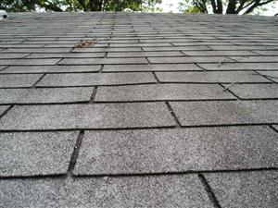
1.2 Picture 1
1.6 Recommend resealing the plumbing vent pipe area for preventive maintenance only.
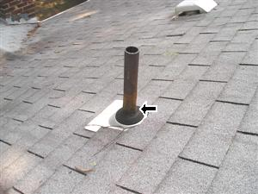
1.6 Picture 1
1.9 The downspout needs an extension or splashblock, for proper water drainage. This is located at the left side of the house (facing front).
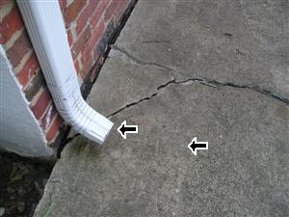
1.9 Picture 1
1.10 (Pictures 1-2) Recommend resealing the flashing area, and remortaring the chimneys as needed. (Picture 3) The rear chimney is not capped to prevent rain and animals from entering the flue. Recommend that this be corrected.
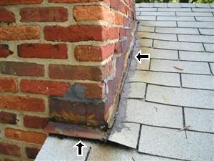  1.10 Picture 1 | 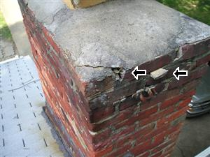  1.10 Picture 2

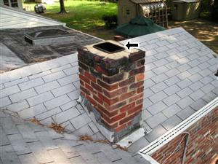
1.10 Picture 3

2. EAVE, SIDING, FOUNDATION WALLS
Y=Yes, N=No, G=GOOD, F=FAIR, RR=REPAIR OR REPLACE, NP=NOT PRESENT, NI=NOT INSPECTED | Styles & Materials  SIDING MATERIAL:  VINYL  BRICK VENEER
   |  | Y | N | G | F | RR | NP | NI
  2.0 | CONDITION OF THE SOFFIT, FASCIA, TRIM AND EAVES |  |  | X
  2.1 | CONDITION OF THE EXTERIOR WALL COVERINGS AND FLASHING |  |  | X
  2.2 | THE CONDITION OF FOUNDATION WALLS AND MORTAR JOINTS (exterior) |  |  |  |  | X
  2.3 | IS OUTSIDE ACCESS TO THE BASEMENT / CRAWLSPACE RODENT PROOF |  | X
  2.4 | ARE THE HOSE-BIBS OPERATIONAL |  | X |  |  | X
  2.5 | CONDITION OF THE EXTERIOR OUTLETS |  |  |  |  | X
  2.6 | ARE THE EXTERIOR OUTLETS GFCI PROTECTED | X
  2.7 | ARE THERE ANY SIGNS OF UNSAFE OR INCORRECT ELECTRICAL WIRING | X |  |  |  | X
  2.8 | CONDITION OF THE GABLE VENTS |  |  | X
  2.9 | CONDITION OF EXTERIOR DRYER OR BATHROOM EXHAUST VENTS |  |  |  | X
  2.10 | IS THERE VEGETATION WITHIN A FOOT OF THE EAVE, SIDING, AND FOUNDATION WALLS |  | X
   |  | Y | N | G | F | RR | NP | NI
Comments:
2.1 Recommend remortaring the exterior brick at the front side of the house.
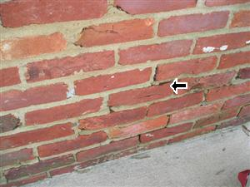
2.1 Picture 1
2.2 (Picture 1) Structural crack in wall at left rear corner (facing rear). The appearance of settlement cracks are large enough for concern. This could be just settlement or a footer issue. Recommend a contractor or "Structural Engineer" to inspect. (Picture 2) Hairline settlement cracks (typical), were found around the exterior foundation of home. Recommend that all settlement cracks that are identified, be properly sealed to prevent any water penetration into the foundation area.
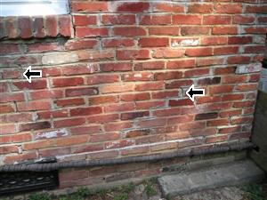  2.2 Picture 1 | 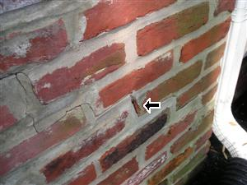  2.2 Picture 2
2.4 The rear exterior hose bib's handle is missing and needs to be corrected.
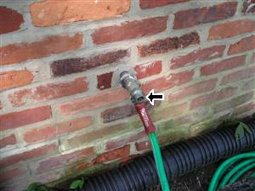
2.4 Picture 1
2.5 Recommend installing an exterior outlet suitable for the shed, instead of running an extension chord from the house to the shed.
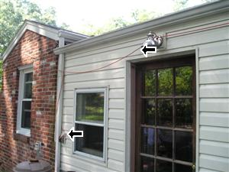  2.5 Picture 1 | 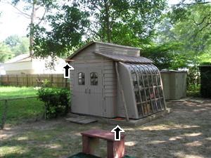  2.5 Picture 2
2.7 The electrical wiring should be capped, and stored into an electrical junction box. This is located at the left corner side of the house (facing front).
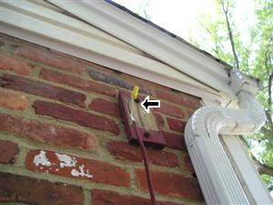
2.7 Picture 1
2.9 Recommend installing a dryer coverguard. This will prevent animals from nesting in this area.
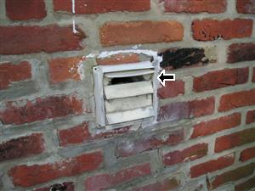
2.9 Picture 1

3. DECKS, BALCONIES, PORCHES, STOOP, STEPS, RAILING
Y=Yes, N=No, G=GOOD, F=FAIR, RR=REPAIR OR REPLACE, NP=NOT PRESENT, NI=NOT INSPECTED | Styles & Materials  APPURTENANCE:  COVERED PORCH  SIDEWALK  DRIVEWAY:  CONCRETE
   |  | Y | N | G | F | RR | NP | NI
  3.0 | PORCH, PATIO, STOOP OR AWNING, STAIRS AND HANDRAILS OR BALCONIES |  |  | X
  3.1 | DECKS, FENCE, STAIRS AND HANDRAILS OR BALCONIES |  |  |  | X
  3.2 | CONDITION OF WALKOUT BASEMENT |  |  |  |  |  | X
  3.3 | CONDITION OF THE CHANGING ROOMS, DECK SHOWER, DECK SAUNA |  |  |  |  |  | X
   |  | Y | N | G | F | RR | NP | NI

4. WINDOWS, DOORS
Y=Yes, N=No, G=GOOD, F=FAIR, RR=REPAIR OR REPLACE, NP=NOT PRESENT, NI=NOT INSPECTED | Styles & Materials  ENTRY DOORS:  WOOD  INTERIOR DOORS:  WOOD  WINDOWS:  WOOD  VINYL  WINDOW TYPES:  DOUBLE-HUNG  SINGLE-HUNG  TILT FEATURE
   |  | Y | N | G | F | RR | NP | NI
  4.0 | THE OUTSIDE APPEARANCE OF THE WINDOWS OR SKYLIGHTS |  |  |  |  | X
  4.1 | SLIDING GLASS DOOR OR PATIO DOORS |  |  |  |  |  | X
  4.2 | THE CONDITION OF FRONT ENTRY DOORS |  |  | X
  4.3 | THE CONDITION OF EXTERIOR ENTRY DOORS |  |  |  |  | X
  4.4 | STORM DOOR OR SCREEN DOOR(S) CONDITION |  |  |  |  | X
  4.5 | WINDOW SCREEN(S) CONDITION |  |  |  | X
  4.6 | CONDITION OF EXTERIOR LIGHT FIXTURES |  |  | X
  4.7 | ARE THE SHUTTERS LOOSE OR DAMAGED |  |  |  |  |  | X
  4.8 | IS THE DOOR CHIME OPERATIONAL |  |  |  |  |  | X
   |  | Y | N | G | F | RR | NP | NI
Comments:
4.0 Because of the structural issue to the rear left corner of the house (facing rear), the structure pulled away from the window causing a gap that needs to be resealed.
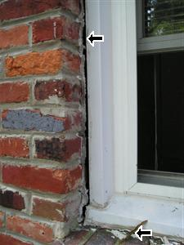  4.0 Picture 1 | 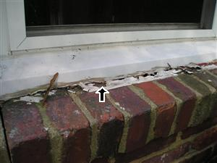  4.0 Picture 2
4.3 Rear entry door at the covered porch, are deteriorated at the bottom of jamb (s). Needs repair.
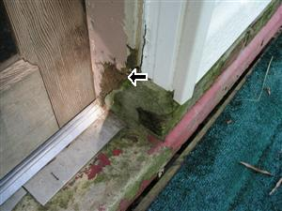
4.3 Picture 1
4.4 The front screen door does not close correctly. Recommend replacing the door handle.
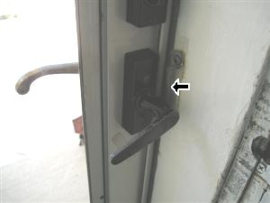
4.4 Picture 1
4.5 There is a small tear in the window screen at the rear window of the house.
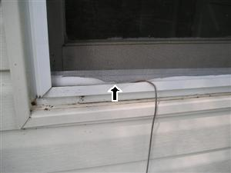
4.5 Picture 1

5. DRIVEWAY, RETAINING WALLS, LANDSCAPING
 |  | Y | N | G | F | RR | NP | NI
5.0 | DOES THE LANDSCAPE FAVOR PROPER DRAINAGE | X
5.1 | WALKWAY |  |  | X
5.2 | DRIVEWAY |  |  |  |  | X
5.3 | WHAT IS THE CONDITION OF THE RETAINING WALL(S) |  |  |  |  |  | X
5.4 | ANY INFREQUENTLY FOUND DISCOVERIES |  | X
 |  | Y | N | G | F | RR | NP | NI
Y=Yes, N=No, G=GOOD, F=FAIR, RR=REPAIR OR REPLACE, NP=NOT PRESENT, NI=NOT INSPECTED
Comments:
5.2 Concrete driveway at the front of the home, has settlement cracks and needs a sealer applied (prep and seal).
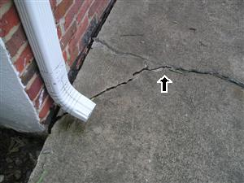
5.2 Picture 1

6. ATTIC AND ROOF STRUCTURE
Y=Yes, N=No, G=GOOD, F=FAIR, RR=REPAIR OR REPLACE, NP=NOT PRESENT, NI=NOT INSPECTED | Styles & Materials  ATTIC FAN:  POWER VENTILATOR  HOUSE FAN:  YES OPERABLE  ATTIC INFO:  PULL DOWN STAIRS  LIGHT IN ATTIC  INSULATION:  BLOWN  FIBERGLASS  R- VALUE:  R-19 OR BETTER  ROOF STRUCTURE:  STICK-BUILT  2 X 6 RAFTERS  WOOD PLANK  CEILING STRUCTURE:  2X6
   |  | Y | N | G | F | RR | NP | NI
  6.0 | IS THERE AN ATTIC ACCESS | X
  6.1 | IS INSULATION IN THE ATTIC | X
  6.2 | DOES THE RAFTERS, COLLARS, WOOD BEAMS, AND SUPPORT STRUTS APPEAR TO BE IN GOOD CONDITION | X
  6.3 | ARE THERE ANY VISIBLE SIGNS OF LEAKS, ABNORMAL CONDENSATION OR DETERIORATION |  | X
  6.4 | IS THERE CORRECT ATTIC VENTILATION | X
  6.5 | IS THERE CROSS-VENTILATION |  | X
  6.6 | IS THERE ANY DEBRIS IN ATTIC |  | X
  6.7 | ARE THERE SIGNS OF ANIMAL FECES IN THE ATTIC |  | X
  6.8 | ARE THERE ANY SIGNS OF ANIMALS OR RODENTS IN THE ATTIC |  | X
  6.9 | IS THERE ANY UNSAFE ELECTRICAL WIRING IN ATTIC |  | X
  6.10 | ARE THE LIGHTING COMPONENTS ADEQUATELY VENTILATED | X
  6.11 | DOES THE VENT PIPES APPEAR TO BE SEALED CORRECTLY | X
  6.12 | DOES THE PLYWOOD, SHEATHING, RIDGE LINE ROOFING MATERIAL APPEAR TO BE IN GOOD CONDITION | X
  6.13 | ARE THE EXHAUST FAN PIPE (s) / TUBING PROPERLY VENTILATED THROUGH THE ATTIC ROOF OR TO THE OUTSIDE | X
  6.14 | IS THE ATTIC INACCESSIBLE FOR INSPECTION |  | X
  6.15 | DOES THE WINDOWS APPEAR TO BE IN GOOD CONDITION |  |  |  |  |  | X
  6.16 | CONDITION OF THE ATTIC DUCTWORK |  |  |  |  |  | X
  6.17 | CONDITION OF THE ATTIC ACCESS |  |  |  |  | X
   |  | Y | N | G | F | RR | NP | NI
Comments:
6.1 Fiberglass (loose-fill) insulation is about six inches thick or just under 19 R-Value. Recommend (for efficiency), that additional insulation be installed for today's set standards of 14-17 inches.
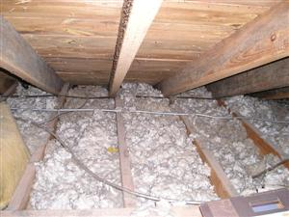
6.1 Picture 1
6.2 The rafters, collars, wood beams, and support struts appear to be in good condition.
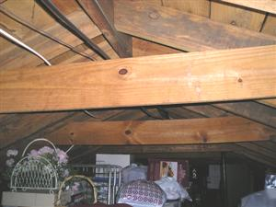
6.2 Picture 1
6.13 View of the bathroom exhaust fan pipe / tubing ventilated through the attic roof or exterior to the house.
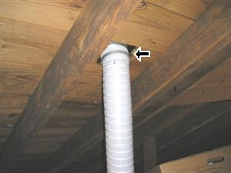
6.13 Picture 1
6.17 The pull-down stairs to the attic is damaged and needs to be repaired or replaced.
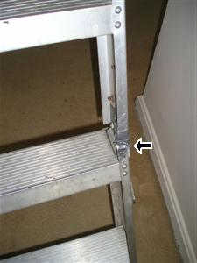
6.17 Picture 1

7. KITCHEN (Coverings
Y=Yes, N=No, G=GOOD, F=FAIR, RR=REPAIR OR REPLACE, NP=NOT PRESENT, NI=NOT INSPECTED | Styles & Materials  CEILING MATERIAL:  SHEETROCK  WALL MATERIAL:  SHEETROCK  FLOOR COVERING(S):  TILE
   |  | Y | N | G | F | RR | NP | NI
  7.0 | COMPLIMENTARY VIEW | X
  7.1 | CEILING |  |  | X
  7.2 | WALLS |  |  | X
  7.3 | FLOOR |  |  | X
  7.4 | DOORS |  |  | X
  7.5 | WINDOWS |  |  |  |  |  | X
  7.6 | PANTRY OR CL0SET DOORS |  |  |  |  |  | X
  7.7 | CONDITION OF THE OUTLETS AND WALL SWITCHES |  |  | X
  7.8 | IS THERE ANY UNSAFE OR INCORRECT ELECTRICAL WIRING | X |  |  |  | X
  7.9 | DOES THE CEILING FAN OR LIGHT FIXTURE APPEAR TO BE OPERATIONAL | X
  7.10 | CONDITION OF THE AIR DISTRIBUTION SCREEN OR RETURN GRILL VENT |  |  | X
   |  | Y | N | G | F | RR | NP | NI
Comments:
7.0 Kitchen complimentary view.
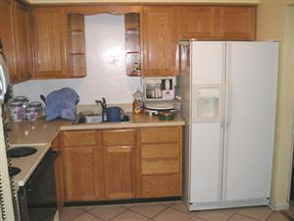
7.0 Picture 1
7.8 (Picture 1) The outlet is a "Hot neutral reverse". The hot and neutral contacts are interchanged. This outlet is located at the opposite wall of the cabinets.
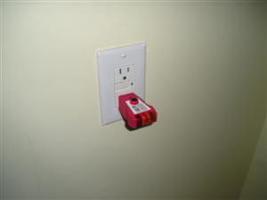
7.8 Picture 1

8. KITCHEN COMPONENTS
Y=Yes, N=No, G=GOOD, F=FAIR, RR=REPAIR OR REPLACE, NP=NOT PRESENT, NI=NOT INSPECTED | Styles & Materials  CABINETRY:  WOOD  COUNTERTOP:  LAMINATE  RANGE/OVEN:  MAYTAG  EXHAUST/RANGE:  GENERAL ELECTRIC  BUILT-IN MICROWAVE:  GENERAL ELECTRIC  REFRIGERATOR:  GENERAL ELECTRIC
   |  | Y | N | G | F | RR | NP | NI
  8.0 | KITCHEN FIXTURES AND APPLIANCES (over-all) |  |  | X
  8.1 | THE CONDITION OF PLUMBING UNDER THE SINK |  |  | X
  8.2 | ARE THERE CUT-OFF VALVES UNDER THE SINK | X
  8.3 | CONDITION OF THE SINK BASE AND CABINETRY |  |  | X
  8.4 | FAUCET AND SPRAY NOZZLE CONDITION |  |  | X
  8.5 | IS THERE A WATER PURIFIER AT KITCHEN SINK |  | X
  8.6 | IS THE DISHWASHER OPERATIONAL |  |  |  |  |  |  | X
  8.7 | IS THE DISPOSER OR TRASH COMPACTOR OPERATIONAL |  |  |  |  |  | X
  8.8 | IS THE COOKTOP/OVEN OR RANGE OPERATIONAL | X
  8.9 | IS THE RANGE VENTILATION OPERATIONAL | X
  8.10 | IS THE OUTLET FOR REFRIGERATOR 3 PRONG GROUNDED OR ACCESSIBLE | X
  8.11 | ARE THE OUTLETS WITHIN SIX FEET OF THE SINK GFCI |  | X |  |  | X
  8.12 | CABINETS AND DRAWERS CONDITION |  |  | X
  8.13 | CONDITION OF COUNTERTOP |  |  | X
  8.14 | CONDITION OF THE REFRIGERATOR |  |  | X
  8.15 | PERMANENTLY INSTALLED MICROWAVES CONDITION |  |  | X
   |  | Y | N | G | F | RR | NP | NI
Comments:
8.6 The portable dishwasher was unplugged and stored in the Laundry Room.
8.11 The GFCI outlet is open/ground. The wire discovered is early Romex wiring. Some of the very earliest versions of Romex were 2-conductor and didn't have the ground wire. The NEC forbids the use of 3-slot outlets when they aren't connected to the grounding circuit. The outlets are in serviceable condition. Recommend an electrician for repair or replace as needed.
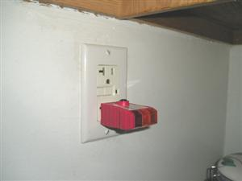
8.11 Picture 1

9(A). MASTER BEDROOM
Y=Yes, N=No, G=GOOD, F=FAIR, RR=REPAIR OR REPLACE, NP=NOT PRESENT, NI=NOT INSPECTED | Styles & Materials  CEILING MATERIAL:  SHEETROCK  WALL MATERIAL:  SHEETROCK  FLOOR COVERING:  CARPET  CLOSET DOORS:  SLIDER (track)  WOOD
   |  | Y | N | G | F | RR | NP | NI
  9.0.A | BEDROOMS COMPLIMENTARY VIEW | X
  9.1.A | CEILING |  |  | X
  9.2.A | WALLS |  |  | X
  9.3.A | FLOORS |  |  | X
  9.4.A | DOORS |  |  |  |  | X
  9.5.A | WINDOWS |  |  | X
  9.6.A | CONDITION OF THE OUTLETS AND WALL SWITCHES |  |  | X
  9.7.A | IS THERE ANY UNSAFE OR INCORRECT ELECTRICAL WIRING |  | X
  9.8.A | CONDITION OF THE AIR DISTRIBUTION SCREEN OR RETURN GRILL VENT |  |  | X
  9.9.A | DOES THE CEILING FAN OR LIGHT FIXTURE APPEAR TO BE OPERATIONAL | X
   |  | Y | N | G | F | RR | NP | NI
Comments:
9.0.A Complimentary view of the Master Bedroom.
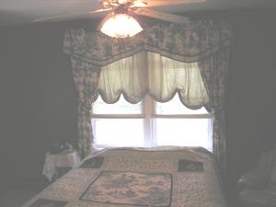
9.0.A Picture 1
9.4.A The Master Bedroom door is missing. Recommend inserting a door.
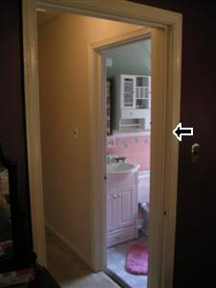
9.4.A Picture 1

9(B). BEDROOM 2
Y=Yes, N=No, G=GOOD, F=FAIR, RR=REPAIR OR REPLACE, NP=NOT PRESENT, NI=NOT INSPECTED | Styles & Materials  CEILING MATERIAL:  SHEETROCK  WALL MATERIAL:  PANELING  FLOOR COVERING:  CARPET  CLOSET DOORS:  SLIDER (track)  WOOD
   |  | Y | N | G | F | RR | NP | NI
  9.0.B | BEDROOMS COMPLIMENTARY VIEW | X
  9.1.B | CEILING |  |  | X
  9.2.B | WALLS |  |  | X
  9.3.B | FLOORS |  |  | X
  9.4.B | DOORS |  |  |  |  | X
  9.5.B | WINDOWS |  |  | X
  9.6.B | CONDITION OF THE OUTLETS AND WALL SWITCHES |  |  | X
  9.7.B | IS THERE ANY UNSAFE OR INCORRECT ELECTRICAL WIRING |  | X
  9.8.B | CONDITION OF THE AIR DISTRIBUTION SCREEN OR RETURN GRILL VENT |  |  | X
  9.9.B | DOES THE CEILING FAN OR LIGHT FIXTURE APPEAR TO BE OPERATIONAL | X
   |  | Y | N | G | F | RR | NP | NI
Comments:
9.0.B Complimentary view of Bedroom 2.
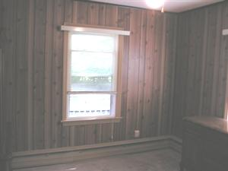
9.0.B Picture 1
9.4.B The Bedroom 2 door is missing. Recommend inserting a door.
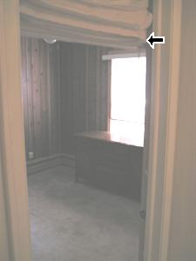
9.4.B Picture 1

9(C). BEDROOM 3
Y=Yes, N=No, G=GOOD, F=FAIR, RR=REPAIR OR REPLACE, NP=NOT PRESENT, NI=NOT INSPECTED | Styles & Materials  CEILING MATERIAL:  SHEETROCK  WALL MATERIAL:  PANELING  FLOOR COVERING:  HARDWOOD T&G  CLOSET DOORS:  WOOD
   |  | Y | N | G | F | RR | NP | NI
  9.0.C | BEDROOMS COMPLIMENTARY VIEW | X
  9.1.C | CEILING |  |  | X
  9.2.C | WALLS |  |  |  | X
  9.3.C | FLOORS |  |  | X
  9.4.C | DOORS |  |  | X
  9.5.C | WINDOWS |  |  | X
  9.6.C | CONDITION OF THE OUTLETS AND WALL SWITCHES |  |  |  |  | X
  9.7.C | IS THERE ANY UNSAFE OR INCORRECT ELECTRICAL WIRING |  | X
  9.8.C | CONDITION OF THE AIR DISTRIBUTION SCREEN OR RETURN GRILL VENT |  |  | X
  9.9.C | DOES THE CEILING FAN OR LIGHT FIXTURE APPEAR TO BE OPERATIONAL | X
   |  | Y | N | G | F | RR | NP | NI
Comments:
9.0.C Complimentary view of Bedroom 3.
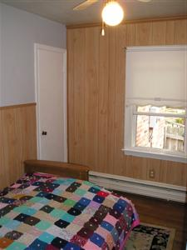
9.0.C Picture 1
9.2.C (Picture 1) Paneling under the window is peeling and needs to be secured. (Picture 2) Closet wall has a hole present.
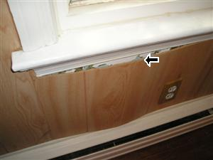  9.2.C Picture 1 | 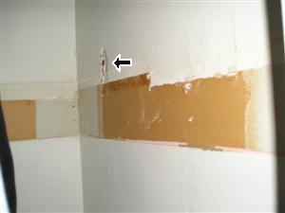  9.2.C Picture 2
9.6.C The lower socket to the outlet, located at the left wall is broken and needs to be replaced.
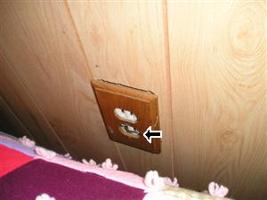
9.6.C Picture 1

10. DINING ROOM (Coverings
Y=Yes, N=No, G=GOOD, F=FAIR, RR=REPAIR OR REPLACE, NP=NOT PRESENT, NI=NOT INSPECTED | Styles & Materials  CEILING MATERIAL:  SHEETROCK  WALL MATERIAL:  PANELING  FLOOR COVERING:  CARPET
   |  | Y | N | G | F | RR | NP | NI
  10.0 | COMPLIMENTARY VIEW | X
  10.1 | CEILING |  |  | X
  10.2 | WALLS |  |  | X
  10.3 | FLOOR |  |  | X
  10.4 | DOORS OR SLIDING GLASS / SCREEN DOORS |  |  |  |  |  | X
  10.5 | WINDOWS |  |  |  |  | X
  10.6 | CONDITION OF THE OUTLETS AND WALL SWITCHES |  |  | X
  10.7 | IS THERE ANY UNSAFE ELECTRICAL WIRING |  | X
  10.8 | DOES THE CEILING FAN / LIGHT FIXTURE APPEAR TO BE OPERATIONAL | X
  10.9 | CONDITION OF THE AIR DISTRIBUTION SCREEN VENT |  |  |  |  |  | X
   |  | Y | N | G | F | RR | NP | NI
Comments:
10.0 Dining Room complimentary view.
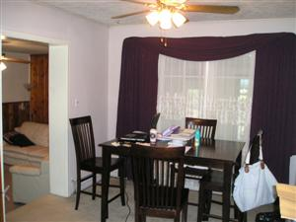
10.0 Picture 1
10.5 The windows are in good condition, but they are bolt locked or tend to stick when trying to be opened. Consult with owner in reference to assuring that all windows open under normal operating standards. This is a safety concern.
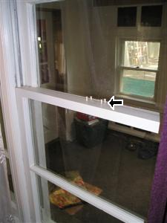
10.5 Picture 1

11(A). LIVING ROOM
Y=Yes, N=No, G=GOOD, F=FAIR, RR=REPAIR OR REPLACE, NP=NOT PRESENT, NI=NOT INSPECTED | Styles & Materials  CEILING MATERIAL:  SHEETROCK  WALL MATERIAL:  SHEETROCK  GLASS  FLOOR COVERING:  CARPET
   |  | Y | N | G | F | RR | NP | NI
  11.0.A | COMPLIMENTARY VIEW | X
  11.1.A | CEILING |  |  | X
  11.2.A | WALLS |  |  | X
  11.3.A | FLOORS |  |  | X
  11.4.A | DOORS |  |  |  |  |  | X
  11.5.A | WINDOWS |  |  | X
  11.6.A | CONDITION OF THE OUTLETS AND WALL SWITCHES |  |  | X
  11.7.A | IS THERE ANY UNSAFE ELECTRICAL WIRING |  | X
  11.8.A | DOES THE CEILING FAN OR LIGHT FIXTURE APPEAR TO BE OPERATIONAL | X
  11.9.A | CONDITION OF THE AIR DISTRIBUTION SCREEN OR RETURN GRILL VENT |  |  | X
   |  | Y | N | G | F | RR | NP | NI
Comments:
11.0.A Complimentary view of the Living Room.
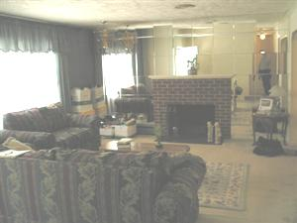
11.0.A Picture 1

11(B). FAMILY ROOM
Y=Yes, N=No, G=GOOD, F=FAIR, RR=REPAIR OR REPLACE, NP=NOT PRESENT, NI=NOT INSPECTED | Styles & Materials  CEILING MATERIAL:  SHEETROCK  WALL MATERIAL:  SHEETROCK  PANELING  FLOOR COVERING:  CARPET
   |  | Y | N | G | F | RR | NP | NI
  11.0.B | COMPLIMENTARY VIEW | X
  11.1.B | CEILING |  |  | X
  11.2.B | WALLS |  |  | X
  11.3.B | FLOORS |  |  | X
  11.4.B | DOORS |  |  |  |  |  | X
  11.5.B | WINDOWS |  |  |  |  | X
  11.6.B | CONDITION OF THE OUTLETS AND WALL SWITCHES |  |  | X
  11.7.B | IS THERE ANY UNSAFE ELECTRICAL WIRING |  | X
  11.8.B | DOES THE CEILING FAN OR LIGHT FIXTURE APPEAR TO BE OPERATIONAL | X
  11.9.B | CONDITION OF THE AIR DISTRIBUTION SCREEN OR RETURN GRILL VENT |  |  | X
   |  | Y | N | G | F | RR | NP | NI
Comments:
11.0.B Complimentary view of the Family Room.
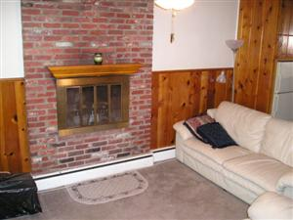
11.0.B Picture 1
11.5.B The windows are in good condition, but they tend to stick when trying to be opened. Consult with owner in reference to assuring that all windows open under normal operating standards. This is a safety concern.
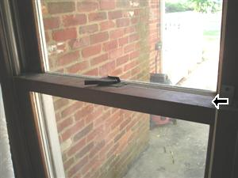
11.5.B Picture 1

12. BATHROOM COMPONENTS
Y=Yes, N=No, G=GOOD, F=FAIR, RR=REPAIR OR REPLACE, NP=NOT PRESENT, NI=NOT INSPECTED | Styles & Materials  EXHAUST FAN TYPES:  FAN WITH LIGHT
   |  | Y | N | G | F | RR | NP | NI
  12.0 | CONDITION OF THE SINK BASE AND CABINETRY |  |  | X
  12.1 | CONDITION OF BATHROOM FIXTURES |  |  | X
  12.2 | CONDITION OF THE PLUMBING FIXTURES |  |  | X
  12.3 | ARE CUT-OFF VALVES UNDER THE SINK AND TOILET | X
  12.4 | DOES THE SINK PLUMBING OPERATE PROPERLY | X
  12.5 | CONDITION OF THE SINK |  |  | X
  12.6 | CONDITION OF THE BATHTUB / SHOWER |  |  | X
  12.7 | CONDITION OF THE SINK FAUCETS AND STOP VALVE |  |  |  |  | X
  12.8 | DOES THE TOILET OPERATE PROPERLY | X |  |  |  | X
  12.9 | DOES THE SHOWER/BATH DRAIN PROPERLY | X
  12.10 | CONDITION OF THE SHOWER, TUB FAUCETS AND STOP VALVE |  |  | X
  12.11 | CAULKING ALONG PERIMETER OF TUB/SHOWER AND FLOOR |  |  |  | X
  12.12 | CAULKING ALONG PERIMETER OF TUB/SHOWER AND WALL |  |  |  | X
  12.13 | IS THE SPACE HEATER OPERATIONAL |  |  |  |  |  | X
   |  | Y | N | G | F | RR | NP | NI
Comments:
12.7 Stop-valve does not operate correctly at Pink Hall Bath sink.
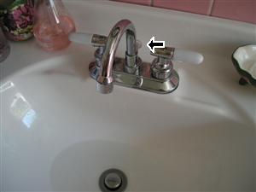
12.7 Picture 1
12.8 Toilet is loose, and may need tightening or repair may involve resetting the toilet on a new wax seal at Pink Hall Bath.
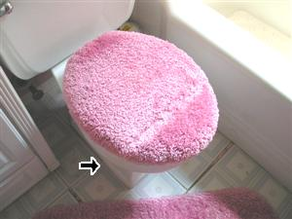
12.8 Picture 1

13. LAUNDRY ROOM
Y=Yes, N=No, G=GOOD, F=FAIR, RR=REPAIR OR REPLACE, NP=NOT PRESENT, NI=NOT INSPECTED | Styles & Materials  CEILING MATERIAL:  CEILING TILES  WALL MATERIAL:  SHEETROCK  FLOOR COVERING:  TILE  DRYER VENT:  METAL  DRYER POWER SOURCE:  22O ELECTRIC  WASHER DRAIN SIZE:  2" DIAMETER
   |  | Y | N | G | F | RR | NP | NI
  13.0 | COMPLIMENTARY VIEW | X
  13.1 | CEILING |  |  | X
  13.2 | WALLS |  |  | X
  13.3 | FLOORS |  |  | X
  13.4 | DOORS |  |  | X
  13.5 | WINDOWS |  |  | X
  13.6 | STAIRWAY |  |  |  |  |  | X
  13.7 | IS THERE ANY UNSAFE OR INCORRECT ELECTRICAL WIRING |  | X
  13.8 | CONDITION OF THE OUTLETS AND WALL SWITCHES |  |  | X
  13.9 | ARE THE OUTLETS WITHIN TWO FEET OF THE SINK GFCI |  |  |  |  |  | X
  13.10 | CONDITION OF THE SINK PLUMBING |  |  |  |  |  | X
  13.11 | CONDITION OF LIGHT FIXTURE |  |  | X
  13.12 | WASHER CONNECTION CONDITION |  |  | X
  13.13 | IS THE WASHER AND DRYER OPERATIONAL, IF IT CONVEYS WITH THE HOME |  |  |  |  |  |  | X
  13.14 | IS THE DRYER VENTILATION EXTENSION PROPERLY INSTALLED AND EXHAUSTING TO THE OUTSIDE | X
   |  | Y | N | G | F | RR | NP | NI
Comments:
13.0 Complimentary view of the Laundry Room.
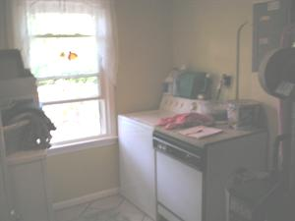
13.0 Picture 1
13.13 The washer was still in use by the seller. Consult with owner, in reference to their operational condition during walk through. The dryer was operational during the home inspection.

14(A). PINK HALL BATH
Y=Yes, N=No, G=GOOD, F=FAIR, RR=REPAIR OR REPLACE, NP=NOT PRESENT, NI=NOT INSPECTED | Styles & Materials  CEILING MATERIAL:  SHEETROCK  WALL MATERIAL:  SHEETROCK  TILE  FLOOR COVERING:  LINOLEUM  TILE
   |  | Y | N | G | F | RR | NP | NI
  14.0.A | COMPLIMENTARY VIEW | X
  14.1.A | CEILING |  |  | X
  14.2.A | WALLS |  |  | X
  14.3.A | FLOORS |  |  |  | X
  14.4.A | DOORS |  |  | X
  14.5.A | WINDOWS |  |  |  |  | X
  14.6.A | CLOSET DOORS |  |  |  |  |  | X
  14.7.A | LIGHT FIXTURES |  |  | X
  14.8.A | CONDITION OF THE CLOSET LIGHT FIXTURE |  |  |  |  |  | X
  14.9.A | ARE THE BATHROOM OUTLETS GFCI PROTECTED |  |  |  |  |  | X
  14.10.A | CONDITION OF ELECTRICAL OUTLET (S) |  |  |  |  |  | X
  14.11.A | IS THERE ANY UNSAFE ELECTRICAL WIRING |  | X
  14.12.A | IS THE EXHAUST FAN IN SERVICEABLE CONDITION |  |  |  |  |  | X
  14.13.A | CONDITION OF THE AIR DISTRIBUTION SCREEN OR RETURN GRILL VENT |  |  | X
   |  | Y | N | G | F | RR | NP | NI
Comments:
14.0.A Complimentary view of the Pink Hall Bath.
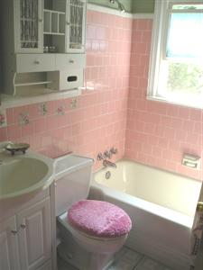
14.0.A Picture 1
14.5.A The left corner of the window frame is deteriorated and needs to be repaired as needed.
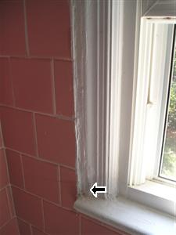
14.5.A Picture 1
14.9.A Did not locate the electrical outlet. If no electrical outlet is present, or a standard electrical outlet is found in the bathroom. Recommend a duplex GFCI outlet be installed by a licensed electrician. GFCI (Ground fault circuit interrupter) outlets are to be placed within 6' of water. This applies to kitchen, bathroom, and garage outlets.

14(B). BLUE HALL BATH
Y=Yes, N=No, G=GOOD, F=FAIR, RR=REPAIR OR REPLACE, NP=NOT PRESENT, NI=NOT INSPECTED | Styles & Materials  CEILING MATERIAL:  SHEETROCK  WALL MATERIAL:  SHEETROCK  TILE  FLOOR COVERING:  LINOLEUM
   |  | Y | N | G | F | RR | NP | NI
  14.0.B | COMPLIMENTARY VIEW | X
  14.1.B | CEILING |  |  | X
  14.2.B | WALLS |  |  | X
  14.3.B | FLOORS |  |  | X
  14.4.B | DOORS |  |  | X
  14.5.B | WINDOWS |  |  |  |  |  | X
  14.6.B | CLOSET DOORS |  |  |  |  |  | X
  14.7.B | LIGHT FIXTURES |  |  | X
  14.8.B | CONDITION OF THE CLOSET LIGHT FIXTURE |  |  |  |  |  | X
  14.9.B | ARE THE BATHROOM OUTLETS GFCI PROTECTED | X
  14.10.B | CONDITION OF ELECTRICAL OUTLET (S) |  |  | X
  14.11.B | IS THERE ANY UNSAFE ELECTRICAL WIRING |  | X
  14.12.B | IS THE EXHAUST FAN IN SERVICEABLE CONDITION | X |  |  |  | X
  14.13.B | CONDITION OF THE AIR DISTRIBUTION SCREEN OR RETURN GRILL VENT |  |  |  |  |  | X
   |  | Y | N | G | F | RR | NP | NI
Comments:
14.0.B Complimentary view of the Blue Hall Bath.
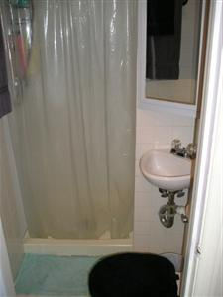
14.0.B Picture 1
14.12.B The exhaust fan is not operating correctly.
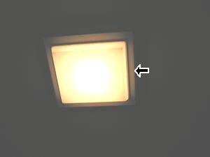
14.12.B Picture 1

15. ELECTRICAL
Y=Yes, N=No, G=GOOD, F=FAIR, RR=REPAIR OR REPLACE, NP=NOT PRESENT, NI=NOT INSPECTED | Styles & Materials  ELECTRICAL CONDUCTORS:  ABOVE GROUND  PANEL CAPACITY:  200 AMP  PANEL TYPE:  CIRCUITS  ELEC. PANEL MANUFACTURER:  CUTLER HAMMER  BRANCH WIRE 15 and 20 AMP:  COPPER  WIRING METHODS:  ROMEX  NUMBER 15 AMPS:  (5)  NUMBER 20 AMPS:  (8)  NUMBER 30 AMPS:  (4)
   |  | Y | N | G | F | RR | NP | NI
  15.0 | SERVICE ENTRANCE CONDUCTORS |  |  | X
  15.1 | SERVICE AND GROUNDING EQUIPMENT, MAIN OVERCURRENT DEVICE, MAIN AND DISTRIBUTION PANELS |  |  | X
  15.2 | IS THERE A BOND WIRE FROM ELECTRICAL PANEL TO METAL PLUMBING | X
  15.3 | DOES THE METERBASE HAVE A GROUND WIRE AND ROD | X
  15.4 | CONDITION OF WIRING, CIRCUITS, OR FUSES INSIDE MAIN PANEL (Branch circuit conductors, Over-current devices, and compatibility of their amperage and voltage) |  |  | X
  15.5 | ARE THE CIRCUITS OR FUSES LABELED CLEARLY | X
  15.6 | ARE THE CIRCUIT BREAKERS OR FUSE BLOCKS THE SAME BRAND NAME AS PANEL | X
  15.7 | DESCRIBE THE LOCATION OF MAIN AND DISTRIBUTION PANELS |  |  | X
  15.8 | ARE SMOKE DETECTORS PRESENT IN THE HOME | X
  15.9 | CONNECTED DEVICES, FIXTURES OR LOOSE WIRING (Observed from a representative number operation of ceiling fans, lighting fixtures, switches and receptacles located inside the house, garage, and on the dwelling's exterior walls) |  |  | X
  15.10 | POLARITY AND GROUNDING OF RECEPTACLES WITHIN 6 FEET OF INTERIOR PLUMBING FIXTURES, AND ALL RECEPTACLES IN GARAGE, CARPORT, EXTERIOR WALLS OF INSPECTED STRUCTURE |  |  | X
  15.11 | OPERATION OF GFCI (GROUND FAULT CIRCUIT INTERRUPTERS) OUTLETS AND CIRCUIT BREAKERS |  |  | X
  15.12 | IS THERE ANY UNSAFE ELECTRICAL WIRING |  | X
   |  | Y | N | G | F | RR | NP | NI
Comments:
15.4 The electrical wiring inside of the main panel appears to be in serviceable condition.
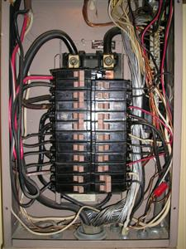
15.4 Picture 1
15.8 Smoke detectors were tested, and should have backup batteries installed before moving into the house.
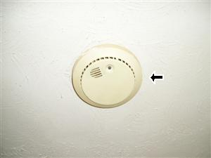
15.8 Picture 1

16. STRUCTURAL COMPONENTS
Y=Yes, N=No, G=GOOD, F=FAIR, RR=REPAIR OR REPLACE, NP=NOT PRESENT, NI=NOT INSPECTED | Styles & Materials  METHOD USED TO OBSERVE CRAWLSPACE:  CRAWLED  FOUNDATION:  BRICK PIERS  WOOD BEAMS  FLOOR STRUCTURE:  2 X 10  WALL STRUCTURE:  MASONRY BLOCK
   |  | Y | N | G | F | RR | NP | NI
  16.0 | FOUNDATION WALLS |  |  |  |  | X
  16.1 | FLOOR STRUCTURE |  |  | X
  16.2 | GIRDERS, PIERS, COLUMNS AND SUPPORTS |  |  | X
  16.3 | IS THE BASEMENT FLOOR CONCRETE SLAB |  |  |  |  |  | X
  16.4 | IS THERE A VAPOR BARRIER ON DIRT FLOOR OF CRAWLSPACE | X
  16.5 | IS THE BASEMENT OR CRAWLSPACE CEILING INSULATED |  | X
  16.6 | ANY DEBRIS IN THE BASEMENT OR CRAWLSPACE | X
  16.7 | ARE THERE FOUNDATION VENTS, DOORS OR WINDOWS | X
  16.8 | ANY WET SIGNS OR UNUSUALLY DAMP AREA |  | X
  16.9 | WERE SOME AREAS OF THE BASEMENT OR CRAWLSPACE INACCESSIBLE | X
  16.10 | ARE THERE ANY VISIBLE SIGNS OF DETERIORATION |  | X
  16.11 | ARE THERE ANY VISIBLE SIGNS OF LEAKS OR ABNORMAL CONDENSATION |  | X
  16.12 | IS THERE ANY UNSAFE ELECTRICAL WIRING |  |  |  |  | X
  16.13 | CRAWLSPACE ACCESS PANEL |  |  |  | X
   |  | Y | N | G | F | RR | NP | NI
Comments:
16.0 Structural crack in wall at left rear corner (facing rear). The appearance of settlement cracks are large enough for concern. This could be just settlement or a footer issue. Recommend a contractor or "Structural Engineer" to inspect.
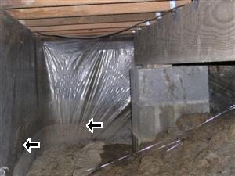
16.0 Picture 1
16.2 The supporting structure is in good condition.
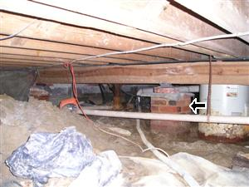
16.2 Picture 1
16.4 There is vapor barrier on 3/4 of the dirt floor, in the crawlspace area. Recommend finishing the rest of the crawlspace correctly. This will reduce moisture from entering the crawlspace area.
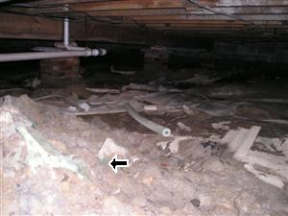
16.4 Picture 1
16.5 The basement ceiling flooring structure is not insulated.
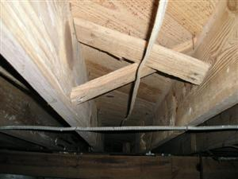
16.5 Picture 1
16.12 Recommend additional outlets in this area, instead of running an extension chord.
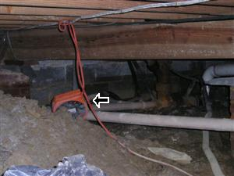
16.12 Picture 1

17. PLUMBING
Y=Yes, N=No, G=GOOD, F=FAIR, RR=REPAIR OR REPLACE, NP=NOT PRESENT, NI=NOT INSPECTED | Styles & Materials  PLUMBING SUPPLY:  NOT VISIBLE  DISTRIBUTION:  COPPER  PLUMBING WASTE:  PVC  CAST IRON (OLD)  WATER SOURCE:  PUBLIC  WATER HEATER POWER SOURCE:  ELECTRIC
   |  | Y | N | G | F | RR | NP | NI
  17.0 | INTERIOR WATER SUPPLY, DISTRIBUTION SYSTEMS AND FIXTURES |  |  | X
  17.1 | INTERIOR DRAIN, WASTE AND VENT SYSTEMS |  |  | X
  17.2 | ANY LEAKS OR CROSS-CONNECTIONS ON THE SUPPLY OR WASTE LINES |  | X
  17.3 | DESCRIBE FUNCTIONAL FLOW (water pressure and volume) |  |  | X
  17.4 | WAS THE MAIN WATER VALVE LOCATED |  | X
  17.5 | WATER HEATER |  |  |  | X
  17.6 | IS WATER HEATER WIRING SECURED PROPERLY | X
  17.7 | IS THE T&P VALVE PIPED WITHIN 6 INCHES OF THE FLOOR |  | X |  |  | X
  17.8 | WAS THE CHIMNEY LINER INSPECTED (for gas/oil water heater only) |  |  |  |  |  | X
  17.9 | IS A WATER PURIFICATION SYSTEM PRESENT |  | X
  17.10 | CONDITION OF THE WELL PUMP PRESSURE TANK |  |  |  |  |  | X
  17.11 | CONDITION OF THE SUMP PUMP |  |  |  |  | X
  17.12 | CONDITION OF THE WATER HEATER STORAGE AREA |  |  |  | X
   |  | Y | N | G | F | RR | NP | NI
Comments:
17.4 Could not locate the main shut-off for water? Please ask the current owners for the location. Otherwise, you will need to use a water key at the street meter or have a plumber install one.
17.5 The water heater is operational. The life expectancy of the average water heater is 8 to 12 years. It appears that the bottom of the tank is rusted. Recommend replacing the water heater in the near future. The water heater is located within the crawlspace area.
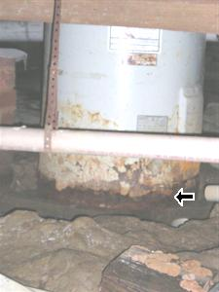
17.5 Picture 1
17.7 T&P (Test and Pressure) valve on water heater needs a 3/4 threaded pipe to extend within 6 inches of floor for safety. (PVC is not approved for hot water use).
17.11 The sump pump was tested and the motor is operational. It appears that the drainage hose may be clogged and the water is not be disposed of correctly. Recommend a plumber for further evaluation, repair or replace as needed.
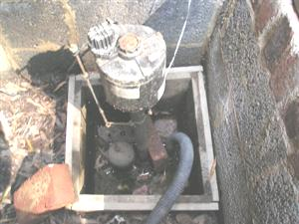
17.11 Picture 1

18. HEATING
Y=Yes, N=No, G=GOOD, F=FAIR, RR=REPAIR OR REPLACE, NP=NOT PRESENT, NI=NOT INSPECTED | Styles & Materials  NUMBER OF HEAT SYSTEMS (excluding wood):  ONE  FUEL SOURCE:  OIL  HEAT TYPE:  OIL FURNACE  BTU RANGE:  100  DUCTWORK:  INSULATED
   |  | Y | N | G | F | RR | NP | NI
  18.0 | THERMOSTATS CONDITION |  |  |  | X
  18.1 | IS THERE A HUMIDIFIER PRESENT |  | X
  18.2 | IS THERE A DEHUMIDIFIER PRESENT |  | X
  18.3 | HEATING EQUIPMENT |  |  | X
  18.4 | COMBUSTION AIR SUPPLY |  |  | X
  18.5 | NORMAL OPERATING CONTROLS |  |  | X
  18.6 | AUTOMATIC SAFETY CONTROLS |  |  | X
  18.7 | ARE CARBON MONOXIDE DETECTORS PRESENT |  |  |  |  |  | X
  18.8 | CHIMNEYS, FLUES AND VENTS (FOR FURNACE) |  |  | X
  18.9 | HEAT DISTRIBUTION SYSTEMS (including fans, pumps, ducts and piping, with supports, insulation, air filters, registers, radiators, fan coil units and convectors) |  |  | X
  18.10 | CONDITION OF EXTERIOR OIL FUEL OR PROPANE GAS TANK(S) |  |  | X
  18.11 | PRESENCE OF INSTALLED HEAT SOURCE IN EACH ROOM |  | X
   |  | Y | N | G | F | RR | NP | NI
Comments:
18.3 The heating equipment is operational. Recommend that gas and oil furnaces be serviced yearly for preventive maintenance only. Model # DBC-100
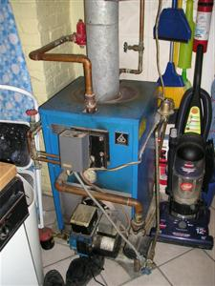
18.3 Picture 1
18.10 View of the exterior oil tank.
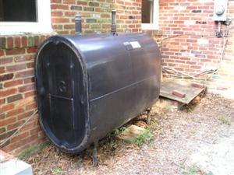
18.10 Picture 1

19. CENTRAL AIR CONDITIONING
Y=Yes, N=No, G=GOOD, F=FAIR, RR=REPAIR OR REPLACE, NP=NOT PRESENT, NI=NOT INSPECTED | Styles & Materials  NUMBER OF A/C UNITS:  ONE  AIR HANDLER UNIT MANUFACTURER:  UNKNOWN
   |  | Y | N | G | F | RR | NP | NI
  19.0 | THERMOSTATS CONDITION |  |  |  | X
  19.1 | COOLING EQUIPMENT |  |  |  | X
  19.2 | AIR HANDLER EQUIPMENT |  |  | X
  19.3 | DOES THE ATTIC FURNACE OR AIR HANDLER SYSTEM HAVE PROPER DRAINAGE | X
  19.4 | NORMAL OPERATING CONTROLS |  |  | X
  19.5 | CONDENSATION LINE OR PUMP'S CONDITION |  |  | X
  19.6 | DISTRIBUTION SYSTEMS (including fans, pumps, ducts and piping, with supports, insulation, air filters, registers, radiators, fan coil units and convectors) |  |  | X
  19.7 | IS THERE ANY UNSAFE ELECTRICAL WIRING |  | X
  19.8 | PRESENCE OF INSTALLED COOLING SOURCE IN EACH ROOM |  | X
  19.9 | IS THERE VEGETATION OR OBSTRUCTION WITHIN A FOOT OF THE CENTRAL AIR CONDITIONING UNIT |  | X
  19.10 | CONDITION OF THE COOLING SUPPORTING STRUCTURE |  |  | X
   |  | Y | N | G | F | RR | NP | NI
Comments:
19.1 The AC unit is operational and cooling correctly. "Optional", to consult with the owner in reference to service paperwork on this unit. Model # 1264-01K, Serial # 1J233960
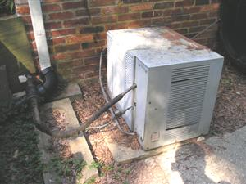
19.1 Picture 1

20. FIREPLACES
Y=Yes, N=No, G=GOOD, F=FAIR, RR=REPAIR OR REPLACE, NP=NOT PRESENT, NI=NOT INSPECTED | Styles & Materials  TYPES OF FIREPLACES:  CONVENTIONAL  OPERABLE FIREPLACES:  TWO
   |  | Y | N | G | F | RR | NP | NI
  20.0 | FIREPLACE OR SOLID FUEL BURNING DEVICES |  |  | X
  20.1 | CONDITION OF THE ELECTRICAL OR MANUAL COMPONENTS |  |  |  |  | X
  20.2 | CLEARANCE TO COMBUSTIBLES |  |  | X
  20.3 | ARE CARBON MONOXIDE DETECTORS PRESENT |  | X
  20.4 | CONDITION OF HEARTH, MANTLE, DOORS AND WALL |  |  | X
  20.5 | DO THE FIRE-BRICK WALLS NEED MORTAR OR REPAIR |  | X
  20.6 | WAS THE LINER INSPECTED OR FULLY VISIBLE FROM END TO END |  | X |  |  | X
   |  | Y | N | G | F | RR | NP | NI
Comments:
20.0 Complimentary view of the fireplaces.
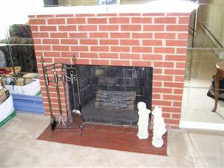  20.0 Picture 1 | 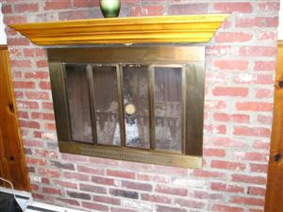  20.0 Picture 2
20.1 The damper to the Living Room's Fireplace, is loose and needs to be tightened.
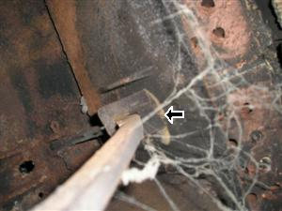
20.1 Picture 1
20.6 Liner was partially inspected by our company from within the house only. We did not inspect the rest of the liner because often it would require disassembly of vent pipe at the vent hood on the roof, or the side of the house. Recommend a certified chimney sweep clean.
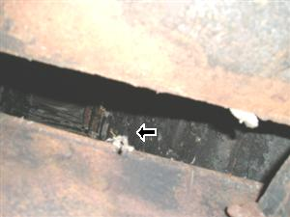
20.6 Picture 1
Prepared Using HomeGauge http://www.homegauge.com SHGI (c) 2000-2004 : Licensed To Scorpion Home Inspections, Inc.

General Summary
Scorpion Home Inspections, Inc.
265 Cedar Ridge Drive
Ruther Glen, VA. 22546
(540) 379-2461
Customer
Investor
Property Address
7831 Martha Washington Street
Alexandria, VA 22309
1 ROOFING, DRAINAGE, CHIMNEYS
1.10 | CONDITION OF THE CHIMNEY AND CHIMNEY FLASHINGS
 | REPAIR OR REPLACE
 | (Pictures 1-2) Recommend resealing the flashing area, and remortaring the chimneys as needed. (Picture 3) The rear chimney is not capped to prevent rain and animals from entering the flue. Recommend that this be corrected.

2 EAVE, SIDING, FOUNDATION WALLS
2.2 | THE CONDITION OF FOUNDATION WALLS AND MORTAR JOINTS (exterior)
 | REPAIR OR REPLACE
 | (Picture 1) Structural crack in wall at left rear corner (facing rear). The appearance of settlement cracks are large enough for concern. This could be just settlement or a footer issue. Recommend a contractor or "Structural Engineer" to inspect. (Picture 2) Hairline settlement cracks (typical), were found around the exterior foundation of home. Recommend that all settlement cracks that are identified, be properly sealed to prevent any water penetration into the foundation area.
2.4 | ARE THE HOSE-BIBS OPERATIONAL
 | No, REPAIR OR REPLACE
 | The rear exterior hose bib's handle is missing and needs to be corrected.
2.5 | CONDITION OF THE EXTERIOR OUTLETS
 | REPAIR OR REPLACE
 | Recommend installing an exterior outlet suitable for the shed, instead of running an extension chord from the house to the shed.
2.7 | ARE THERE ANY SIGNS OF UNSAFE OR INCORRECT ELECTRICAL WIRING
 | Yes, REPAIR OR REPLACE
 | The electrical wiring should be capped, and stored into an electrical junction box. This is located at the left corner side of the house (facing front).

4 WINDOWS, DOORS
4.0 | THE OUTSIDE APPEARANCE OF THE WINDOWS OR SKYLIGHTS
 | REPAIR OR REPLACE
 | Because of the structural issue to the rear left corner of the house (facing rear), the structure pulled away from the window causing a gap that needs to be resealed.
4.3 | THE CONDITION OF EXTERIOR ENTRY DOORS
 | REPAIR OR REPLACE
 | Rear entry door at the covered porch, are deteriorated at the bottom of jamb (s). Needs repair.
4.4 | STORM DOOR OR SCREEN DOOR(S) CONDITION
 | REPAIR OR REPLACE
 | The front screen door does not close correctly. Recommend replacing the door handle.

5 DRIVEWAY, RETAINING WALLS, LANDSCAPING
5.2 | DRIVEWAY
 | REPAIR OR REPLACE
 | Concrete driveway at the front of the home, has settlement cracks and needs a sealer applied (prep and seal).

6 ATTIC AND ROOF STRUCTURE
6.17 | CONDITION OF THE ATTIC ACCESS
 | REPAIR OR REPLACE
 | The pull-down stairs to the attic is damaged and needs to be repaired or replaced.

7 KITCHEN (Coverings
7.8 | IS THERE ANY UNSAFE OR INCORRECT ELECTRICAL WIRING
 | Yes, REPAIR OR REPLACE
 | (Picture 1) The outlet is a "Hot neutral reverse". The hot and neutral contacts are interchanged. This outlet is located at the opposite wall of the cabinets.

8 KITCHEN COMPONENTS
8.6 | IS THE DISHWASHER OPERATIONAL
 | NOT INSPECTED
 | The portable dishwasher was unplugged and stored in the Laundry Room.
8.11 | ARE THE OUTLETS WITHIN SIX FEET OF THE SINK GFCI
 | No, REPAIR OR REPLACE
 | The GFCI outlet is open/ground. The wire discovered is early Romex wiring. Some of the very earliest versions of Romex were 2-conductor and didn't have the ground wire. The NEC forbids the use of 3-slot outlets when they aren't connected to the grounding circuit. The outlets are in serviceable condition. Recommend an electrician for repair or replace as needed.

9(A) MASTER BEDROOM
9.4.A | DOORS
 | REPAIR OR REPLACE
 | The Master Bedroom door is missing. Recommend inserting a door.

9(B) BEDROOM 2
9.4.B | DOORS
 | REPAIR OR REPLACE
 | The Bedroom 2 door is missing. Recommend inserting a door.

9(C) BEDROOM 3
9.6.C | CONDITION OF THE OUTLETS AND WALL SWITCHES
 | REPAIR OR REPLACE
 | The lower socket to the outlet, located at the left wall is broken and needs to be replaced.

10 DINING ROOM (Coverings
10.5 | WINDOWS
 | REPAIR OR REPLACE
 | The windows are in good condition, but they are bolt locked or tend to stick when trying to be opened. Consult with owner in reference to assuring that all windows open under normal operating standards. This is a safety concern.

11(B) FAMILY ROOM
11.5.B | WINDOWS
 | REPAIR OR REPLACE
 | The windows are in good condition, but they tend to stick when trying to be opened. Consult with owner in reference to assuring that all windows open under normal operating standards. This is a safety concern.

12 BATHROOM COMPONENTS
12.7 | CONDITION OF THE SINK FAUCETS AND STOP VALVE
 | REPAIR OR REPLACE
 | Stop-valve does not operate correctly at Pink Hall Bath sink.
12.8 | DOES THE TOILET OPERATE PROPERLY
 | Yes, REPAIR OR REPLACE
 | Toilet is loose, and may need tightening or repair may involve resetting the toilet on a new wax seal at Pink Hall Bath.

13 LAUNDRY ROOM
13.13 | IS THE WASHER AND DRYER OPERATIONAL, IF IT CONVEYS WITH THE HOME
 | NOT INSPECTED
 | The washer was still in use by the seller. Consult with owner, in reference to their operational condition during walk through. The dryer was operational during the home inspection.

14(A) PINK HALL BATH
14.5.A | WINDOWS
 | REPAIR OR REPLACE
 | The left corner of the window frame is deteriorated and needs to be repaired as needed.

14(B) BLUE HALL BATH
14.12.B | IS THE EXHAUST FAN IN SERVICEABLE CONDITION
 | Yes, REPAIR OR REPLACE
 | The exhaust fan is not operating correctly.

16 STRUCTURAL COMPONENTS
16.0 | FOUNDATION WALLS
 | REPAIR OR REPLACE
 | Structural crack in wall at left rear corner (facing rear). The appearance of settlement cracks are large enough for concern. This could be just settlement or a footer issue. Recommend a contractor or "Structural Engineer" to inspect.
16.12 | IS THERE ANY UNSAFE ELECTRICAL WIRING
 | REPAIR OR REPLACE
 | Recommend additional outlets in this area, instead of running an extension chord.

17 PLUMBING
17.7 | IS THE T&P VALVE PIPED WITHIN 6 INCHES OF THE FLOOR
 | No, REPAIR OR REPLACE
 | T&P (Test and Pressure) valve on water heater needs a 3/4 threaded pipe to extend within 6 inches of floor for safety. (PVC is not approved for hot water use).
17.11 | CONDITION OF THE SUMP PUMP
 | REPAIR OR REPLACE
 | The sump pump was tested and the motor is operational. It appears that the drainage hose may be clogged and the water is not be disposed of correctly. Recommend a plumber for further evaluation, repair or replace as needed.

20 FIREPLACES
20.1 | CONDITION OF THE ELECTRICAL OR MANUAL COMPONENTS
 | REPAIR OR REPLACE
 | The damper to the Living Room's Fireplace, is loose and needs to be tightened.
20.6 | WAS THE LINER INSPECTED OR FULLY VISIBLE FROM END TO END
 | No, REPAIR OR REPLACE
 | Liner was partially inspected by our company from within the house only. We did not inspect the rest of the liner because often it would require disassembly of vent pipe at the vent hood on the roof, or the side of the house. Recommend a certified chimney sweep clean.

Prepared Using HomeGauge http://www.homegauge.com SHGI (c) 2000-2004 : Licensed To Scorpion Home Inspections, Inc.

INVOICE

Scorpion Home Inspections, Inc.  265 Cedar Ridge Drive  Ruther Glen, VA. 22546  (540) 379-2461  Inspected By: Michael Edwards | Inspection Date: 8/14/2006  Report ID: 1382-0806

Customer Info: | Inspection Property:
Investor  555 Home Inspection Avenue  Fredericksburg VA 22401  Customer's Real Estate Professional:  Harry & Linda Bradley  RE/MAX Allegiance | 7831 Martha Washington Street  Alexandria, VA 22309
Inspection Fee:
Service
Price | Amount | Sub-Total
Heated Sq Feet 2,001 - 2,500 | 270.00 | 1 | 270.00

Tax $0.00
Total Price $270.00
Payment Method:Check
Payment Status:Paid At Time Of Inspection
Note:

Scorpion Home Inspections, Inc.
265 Cedar Ridge Drive
Ruther Glen, VA. 22546
(540) 379-2461

Report Attachments
Pre-Inspection Agreement
2nd page of the Pre-Inspection Agreement

Scorpion Home Inspections, Inc.
Michael Edwards
265 Cedar Ridge Drive
Ruther Glen, VA. 22546
(540) 379-2461

Inspection Agreement
This inspection was performed in accordance with and under the terms of a Pre-Inspection Agreement. The agreement was signed and agreed upon before the preparation of this report and a signed copy of the agreement is available upon request. An unsigned copy of the agreement may be attached to this report for your information or it may also be available on the home inspection company web site.

